Project 2015: Building a Working Game of Chess

Screen Shots
Student Name: Student Number:
Please provide at least one screen shot of each of the following scenarios.
- Initial set up of board
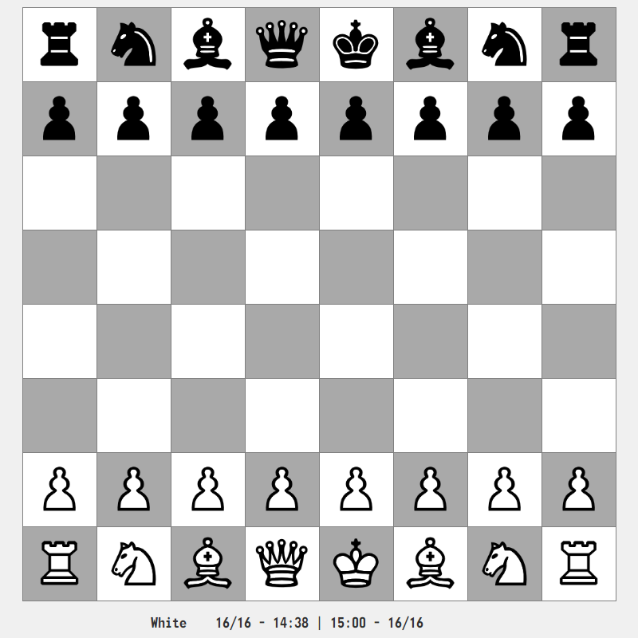

- Check (with notification)
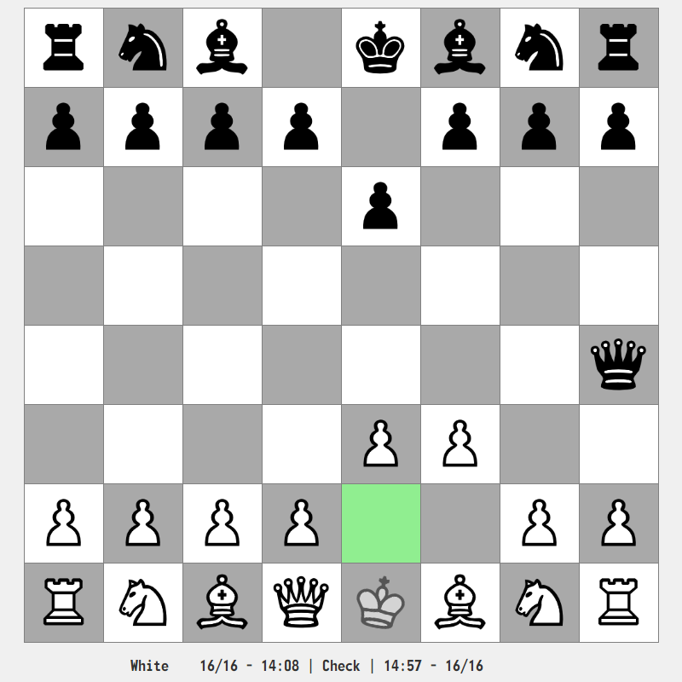

- Checkmate (with notification)
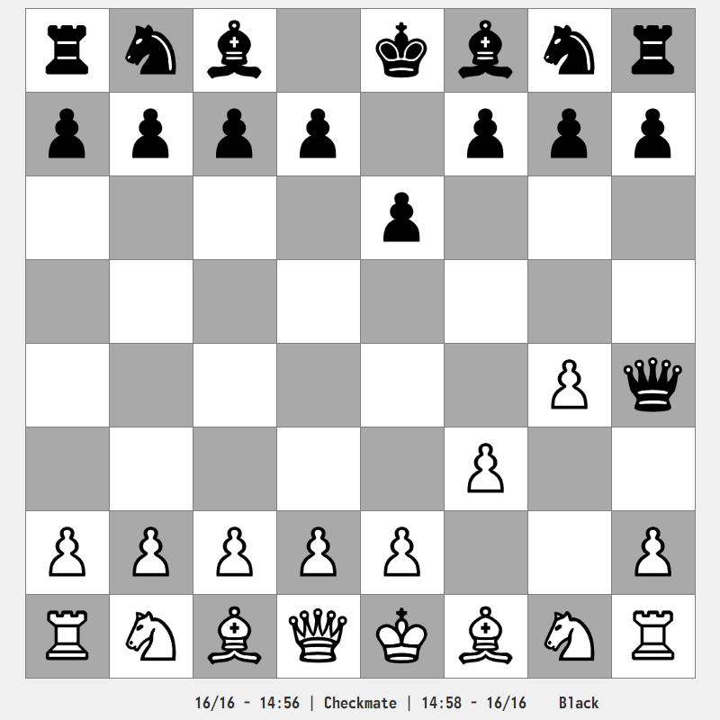

- Stalemate (with notification)
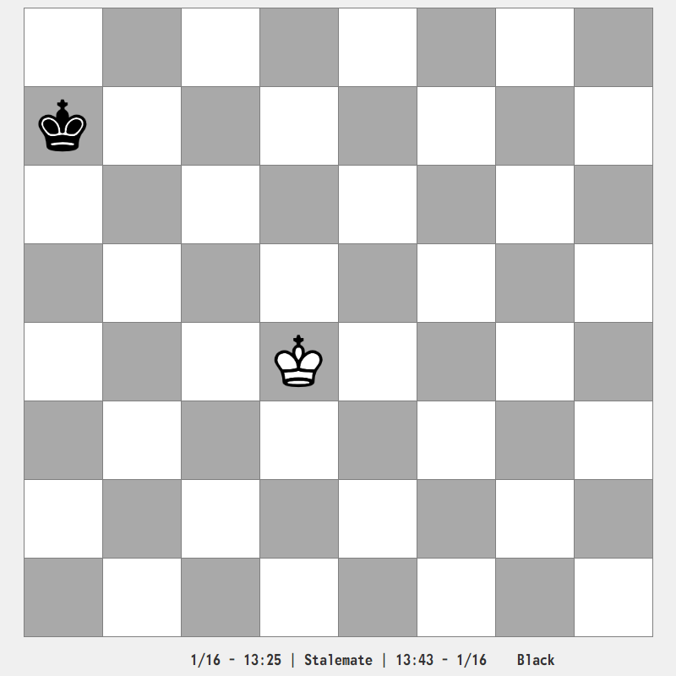

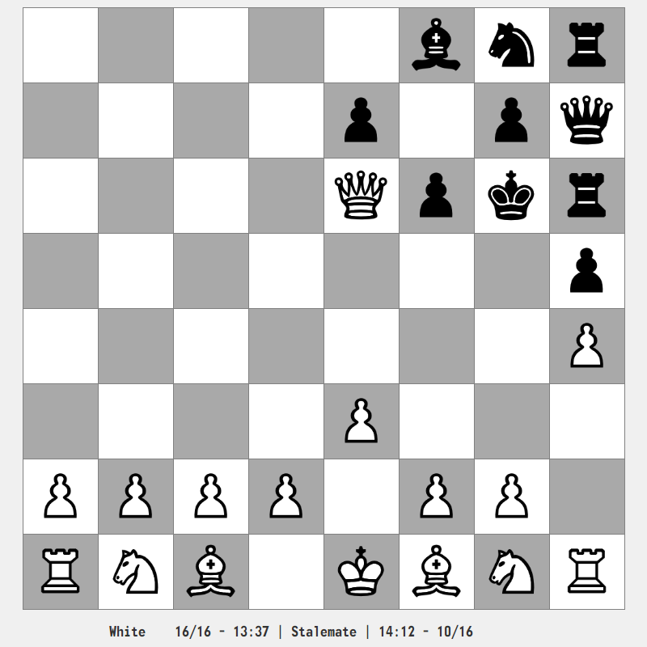
- Bonuses (see README.md file)

En passant
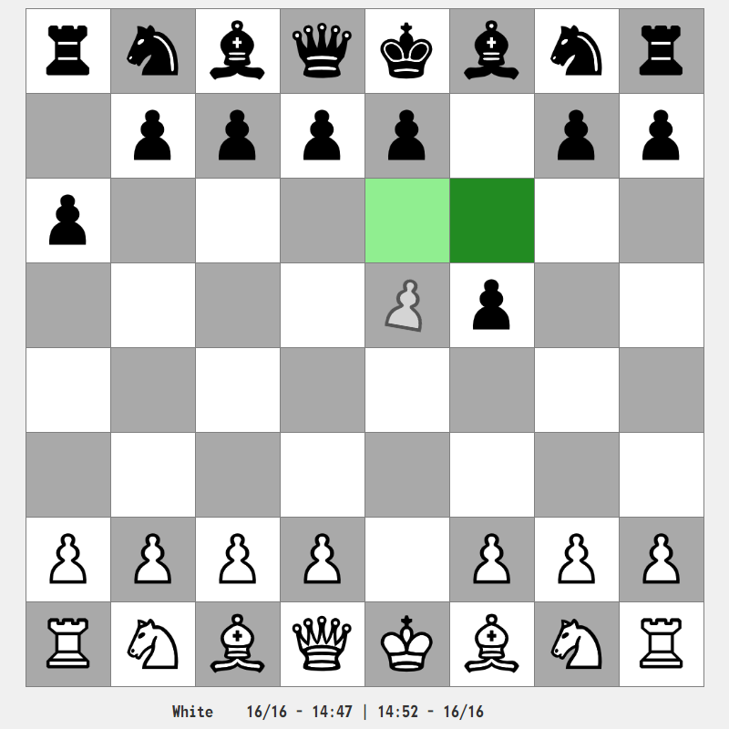

Castling
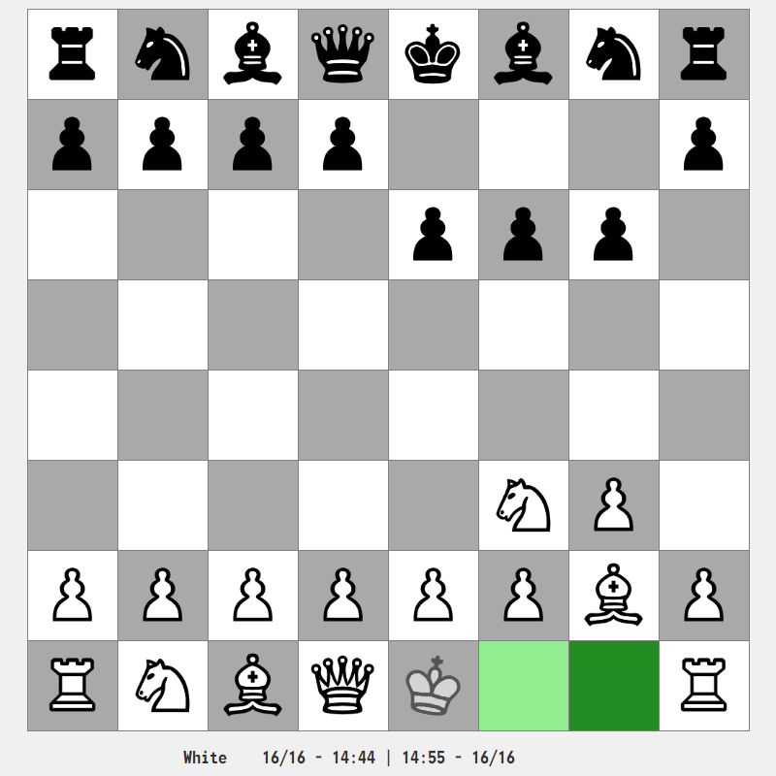

Promotion
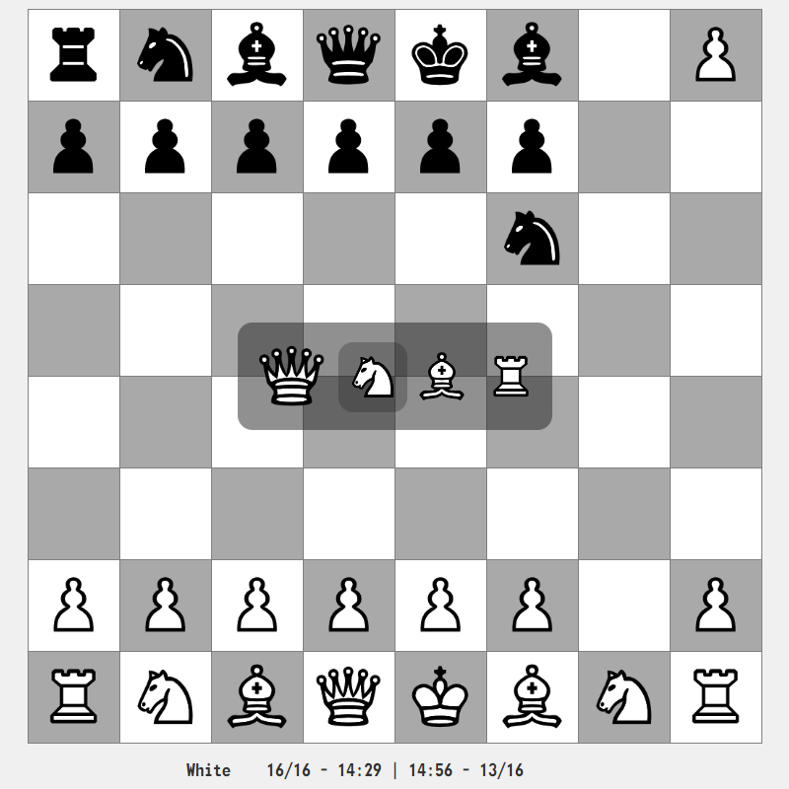

Menu (ESCAP)
